Test Case: tc003_SPX_Dev5_Crear_Requisicion_Spot_Tipo_Cobro_CC_Urgent
Step 1 - Enter username and password and click to button Enter : Credentials Entered
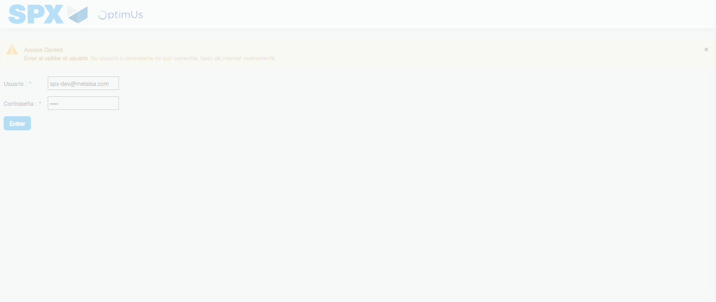Image file-name: QC_Testing-tc003_SPX_Dev5_Crear_Requisicion_Spot_Tipo_Cobro_CC_Urgent-1782239147762

Step 2 - Select to UEN and Access to Spot Buy Requisitions : UEN Correctly selected and Correct access
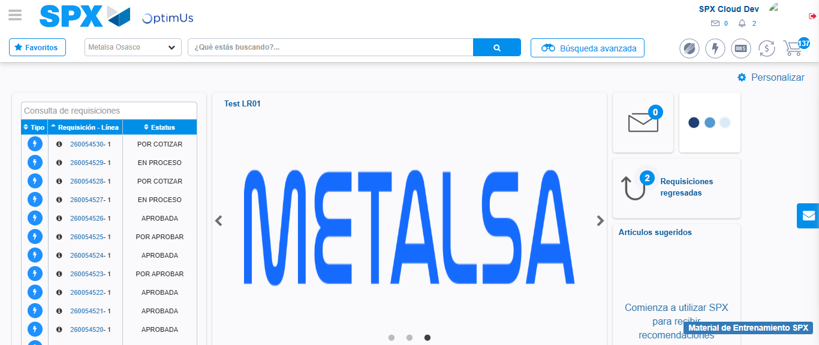Image file-name: QC_Testing-tc003_SPX_Dev5_Crear_Requisicion_Spot_Tipo_Cobro_CC_Urgent-1782239173563

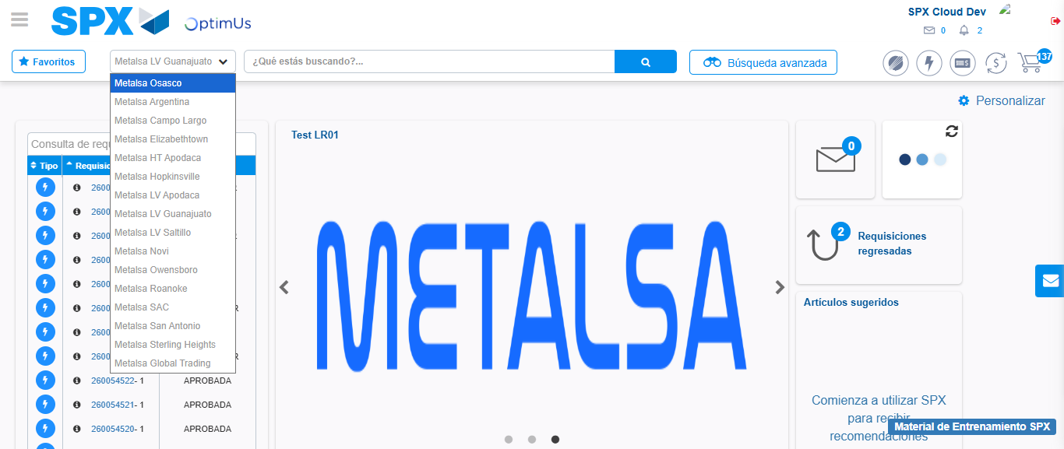Image file-name: QC_Testing-tc003_SPX_Dev5_Crear_Requisicion_Spot_Tipo_Cobro_CC_Urgent-1782239176115

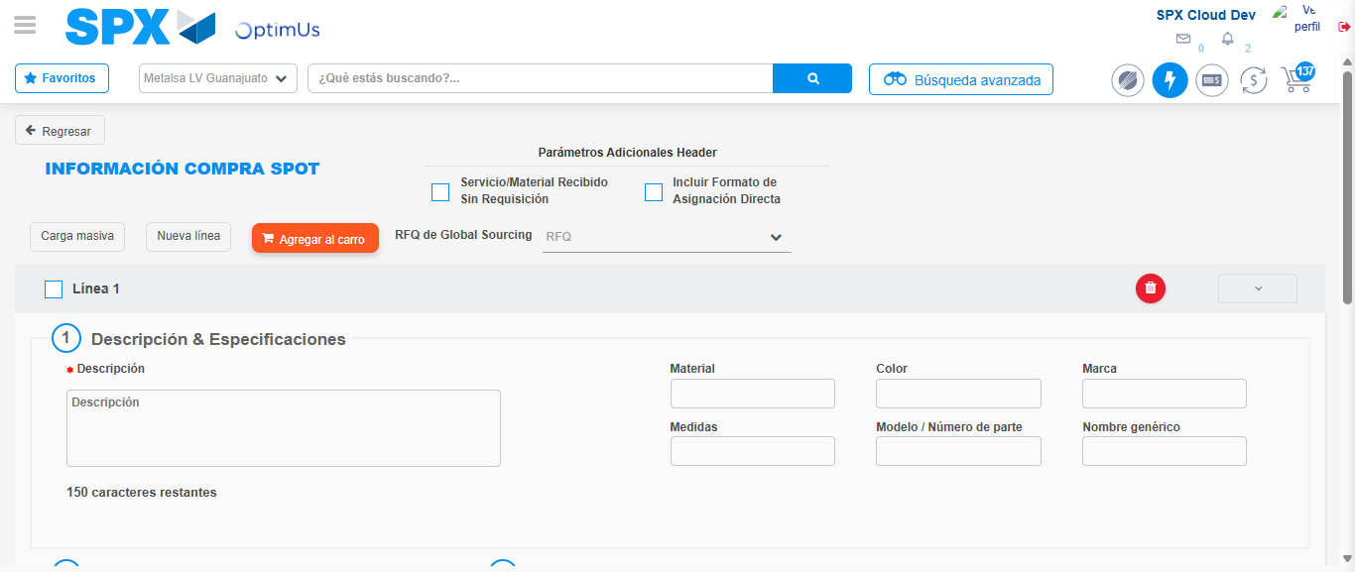Image file-name: QC_Testing-tc003_SPX_Dev5_Crear_Requisicion_Spot_Tipo_Cobro_CC_Urgent-1782239203458

Step 3 - Data Capture Spot Buy Requisition: Data captured correctly
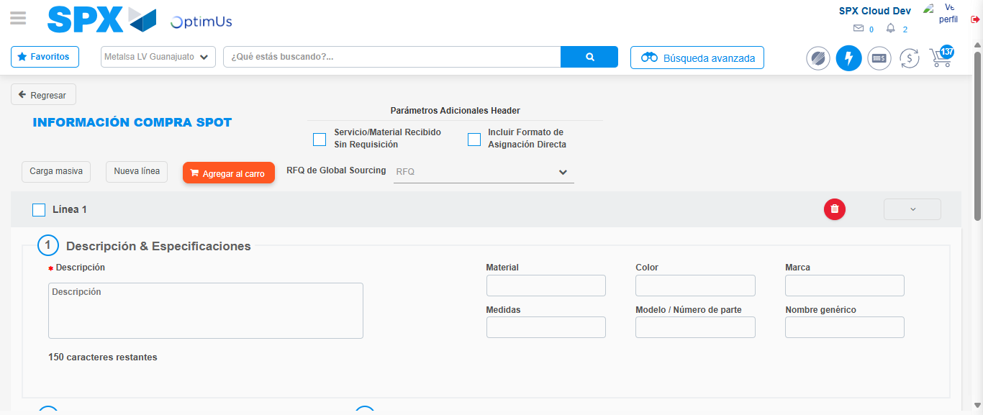Image file-name: QC_Testing-tc003_SPX_Dev5_Crear_Requisicion_Spot_Tipo_Cobro_CC_Urgent-1782239203774

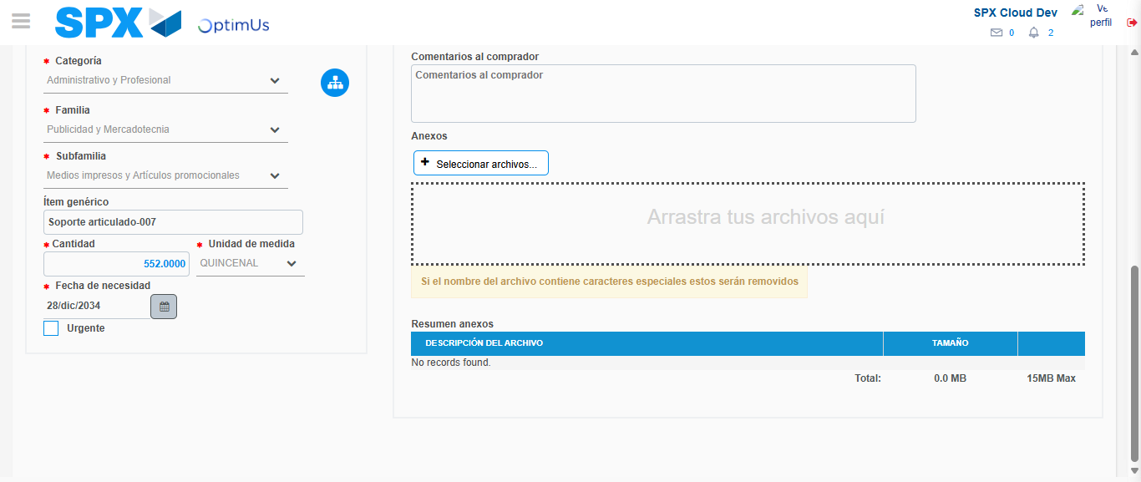Image file-name: QC_Testing-tc003_SPX_Dev5_Crear_Requisicion_Spot_Tipo_Cobro_CC_Urgent-1782239214065

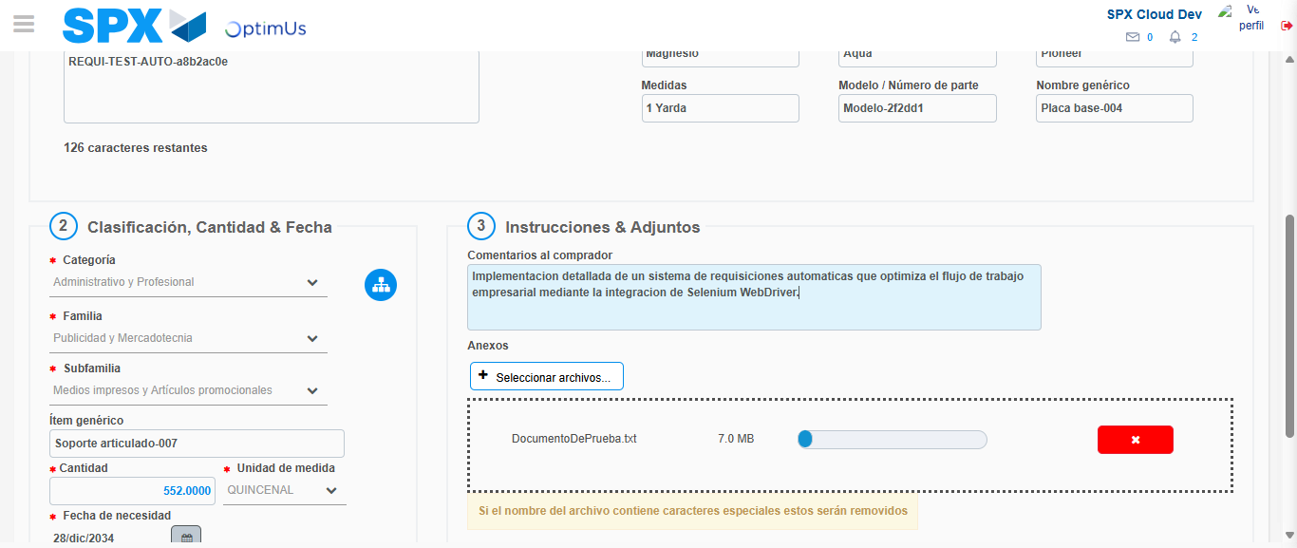Image file-name: QC_Testing-tc003_SPX_Dev5_Crear_Requisicion_Spot_Tipo_Cobro_CC_Urgent-1782239214948

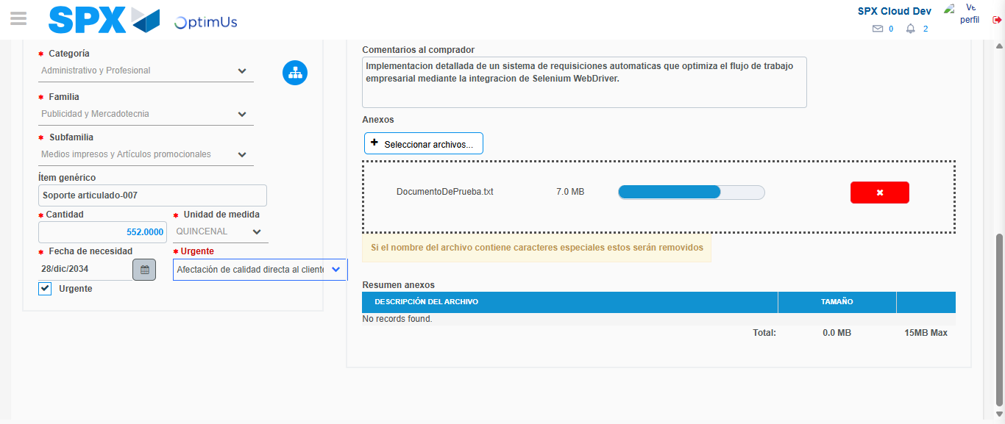Image file-name: QC_Testing-tc003_SPX_Dev5_Crear_Requisicion_Spot_Tipo_Cobro_CC_Urgent-1782239219101

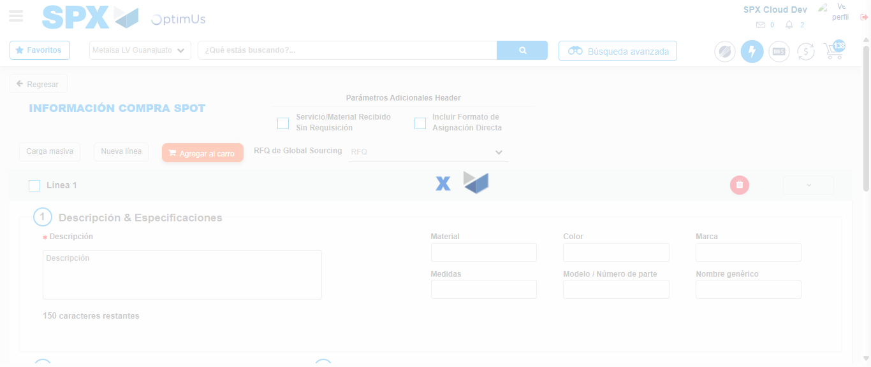Image file-name: QC_Testing-tc003_SPX_Dev5_Crear_Requisicion_Spot_Tipo_Cobro_CC_Urgent-1782239221517

Step 4 - Select to Requisition: Requisition Correctly selected
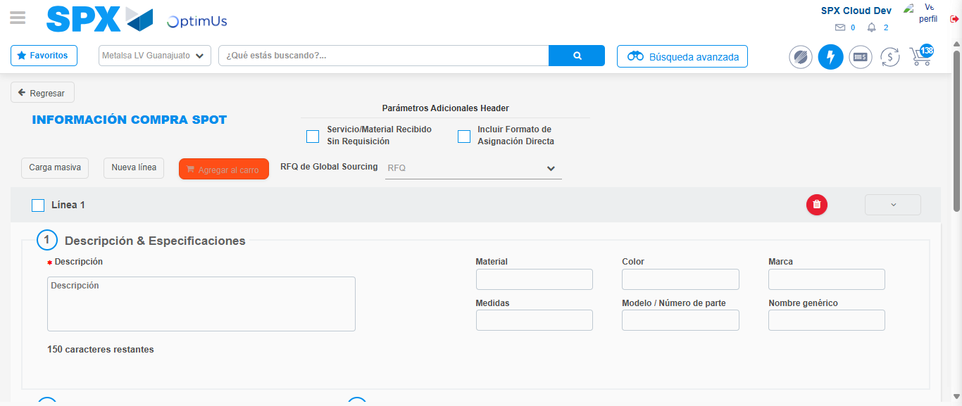Image file-name: QC_Testing-tc003_SPX_Dev5_Crear_Requisicion_Spot_Tipo_Cobro_CC_Urgent-1782239221747

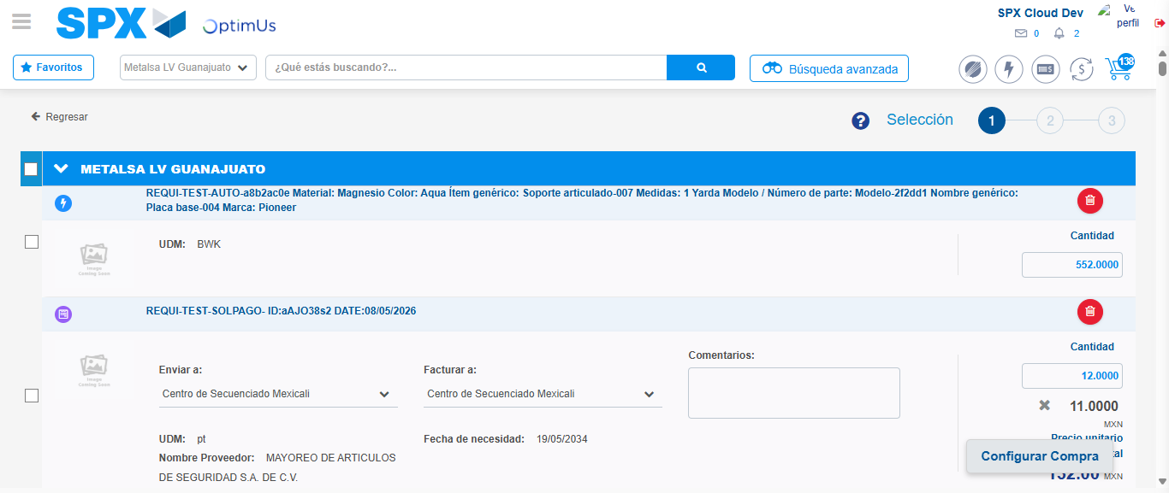Image file-name: QC_Testing-tc003_SPX_Dev5_Crear_Requisicion_Spot_Tipo_Cobro_CC_Urgent-1782239233704

Image file-name: QC_Testing-tc003_SPX_Dev5_Crear_Requisicion_Spot_Tipo_Cobro_CC_Urgent-1782239233915

Image file-name: QC_Testing-tc003_SPX_Dev5_Crear_Requisicion_Spot_Tipo_Cobro_CC_Urgent-1782239234104

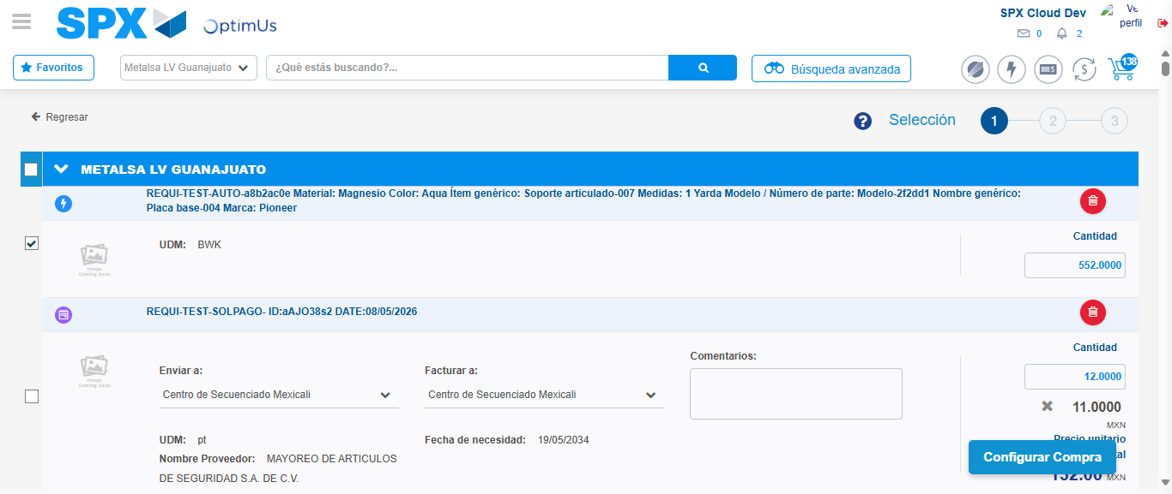Image file-name: QC_Testing-tc003_SPX_Dev5_Crear_Requisicion_Spot_Tipo_Cobro_CC_Urgent-1782239235957

Step 5 - Select Type Account For Requisition: Type Account Correctly selected
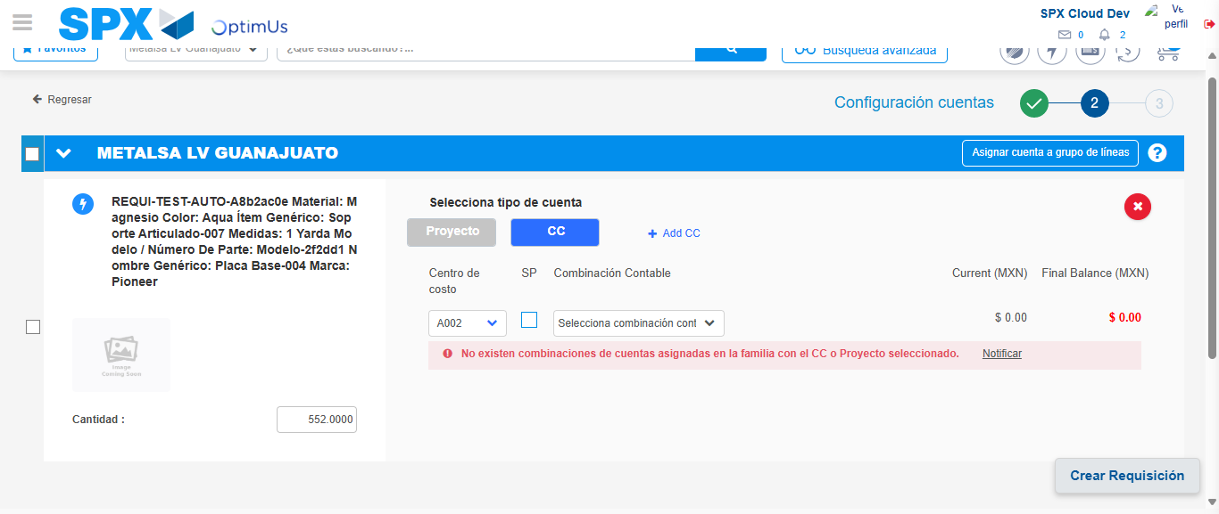Image file-name: QC_Testing-tc003_SPX_Dev5_Crear_Requisicion_Spot_Tipo_Cobro_CC_Urgent-1782239251601

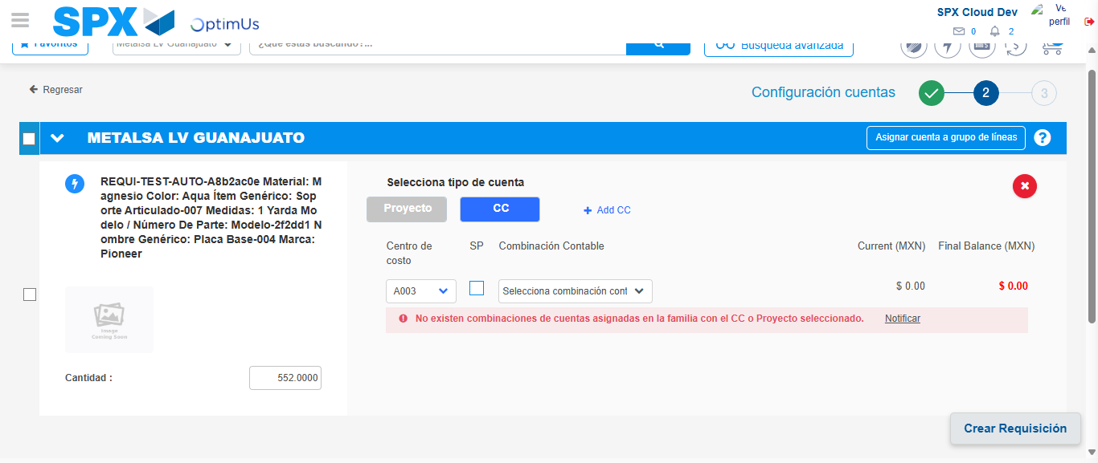Image file-name: QC_Testing-tc003_SPX_Dev5_Crear_Requisicion_Spot_Tipo_Cobro_CC_Urgent-1782239256463

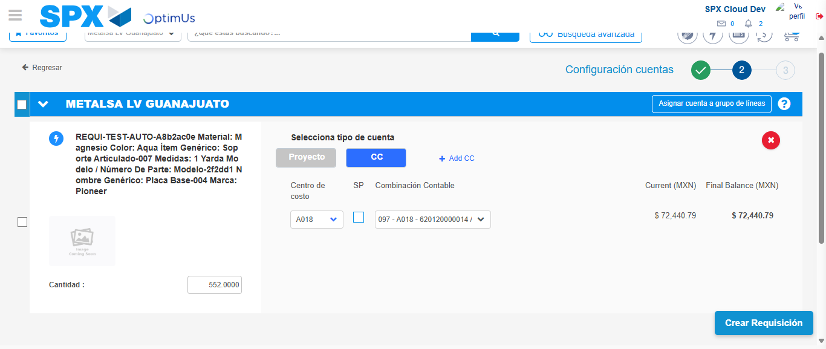Image file-name: QC_Testing-tc003_SPX_Dev5_Crear_Requisicion_Spot_Tipo_Cobro_CC_Urgent-1782239261163

Image file-name: QC_Testing-tc003_SPX_Dev5_Crear_Requisicion_Spot_Tipo_Cobro_CC_Urgent-1782239261331

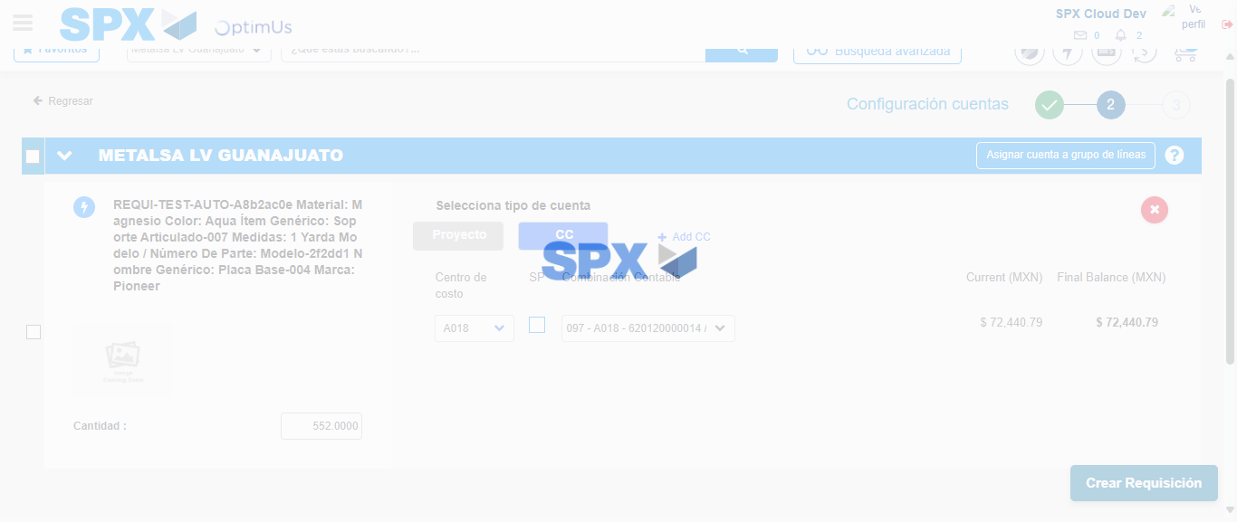Image file-name: QC_Testing-tc003_SPX_Dev5_Crear_Requisicion_Spot_Tipo_Cobro_CC_Urgent-1782239261679

Step 6 - Accept to Requisition: Requisition Accepted
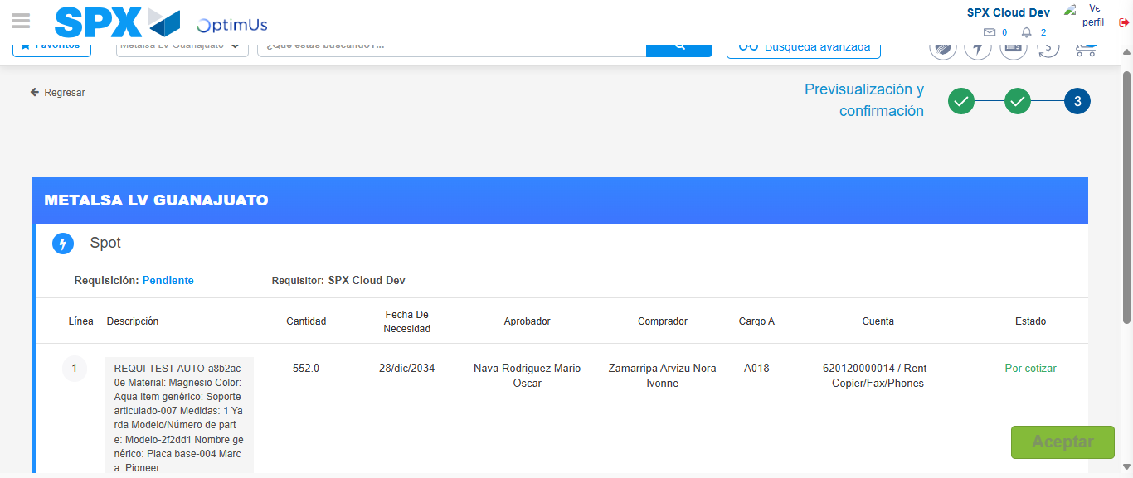Image file-name: QC_Testing-tc003_SPX_Dev5_Crear_Requisicion_Spot_Tipo_Cobro_CC_Urgent-1782239262507

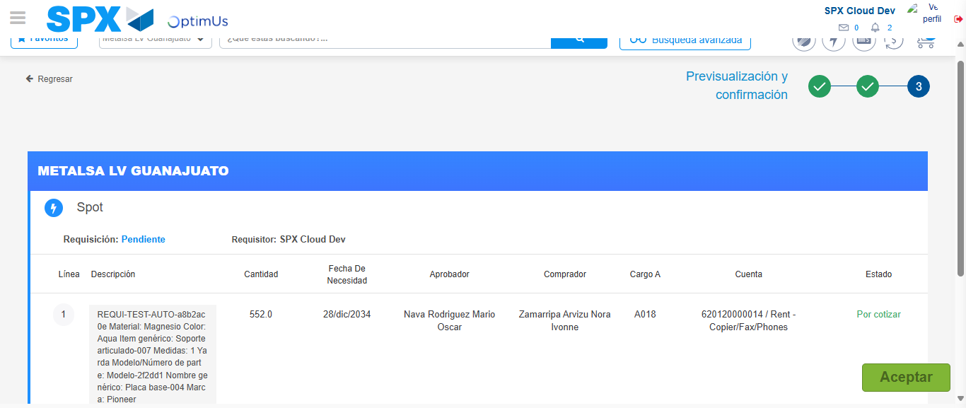Image file-name: QC_Testing-tc003_SPX_Dev5_Crear_Requisicion_Spot_Tipo_Cobro_CC_Urgent-1782239262703

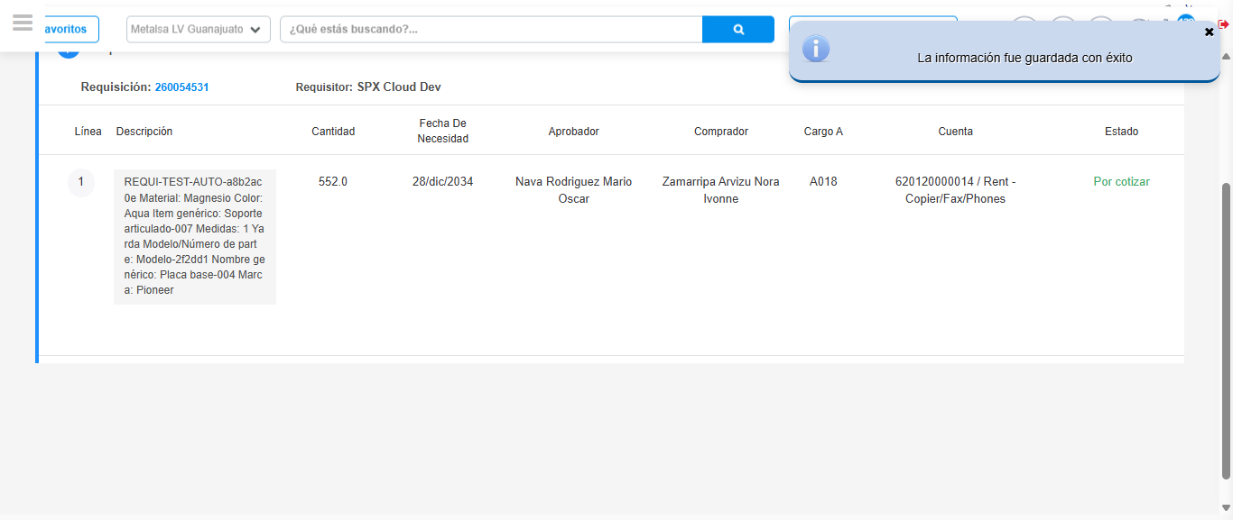Image file-name: QC_Testing-tc003_SPX_Dev5_Crear_Requisicion_Spot_Tipo_Cobro_CC_Urgent-1782239265641

Step 7 - Return to Main Page SPX : Return to Main Page SPX
Image file-name: QC_Testing-tc003_SPX_Dev5_Crear_Requisicion_Spot_Tipo_Cobro_CC_Urgent-1782239173563

Image file-name: QC_Testing-tc003_SPX_Dev5_Crear_Requisicion_Spot_Tipo_Cobro_CC_Urgent-1782239176115

Image file-name: QC_Testing-tc003_SPX_Dev5_Crear_Requisicion_Spot_Tipo_Cobro_CC_Urgent-1782239203458

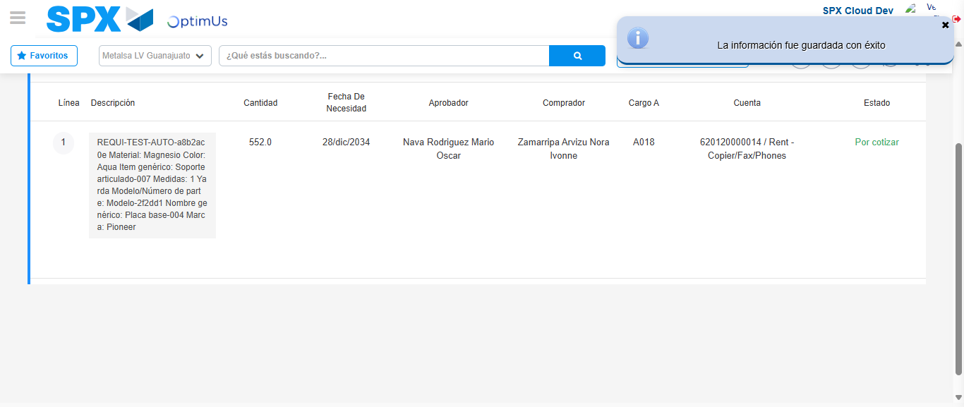Image file-name: QC_Testing-tc003_SPX_Dev5_Crear_Requisicion_Spot_Tipo_Cobro_CC_Urgent-1782239267849

Image file-name: QC_Testing-tc003_SPX_Dev5_Crear_Requisicion_Spot_Tipo_Cobro_CC_Urgent-1782239267976

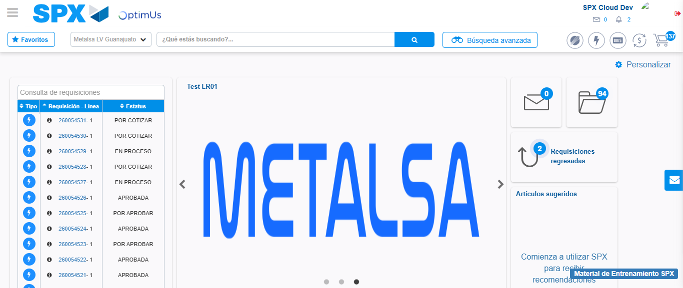Image file-name: QC_Testing-tc003_SPX_Dev5_Crear_Requisicion_Spot_Tipo_Cobro_CC_Urgent-1782239289069

Step 8 - Log Out : Log Out SPX
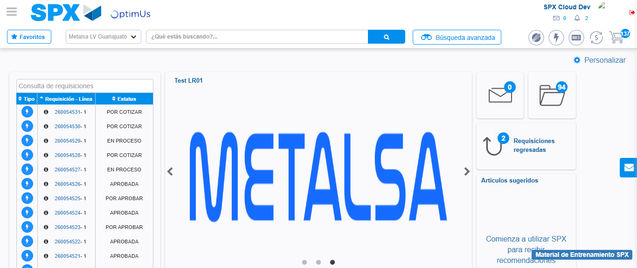Image file-name: QC_Testing-tc003_SPX_Dev5_Crear_Requisicion_Spot_Tipo_Cobro_CC_Urgent-1782239289315

